Blockchain
Made By Masud Rana Mushfiq

Contents at a Glance:
This note covers the following major topics:

Slide 01:

Blockchain is a digital ledger technology that provides a secure, transparent, and decentralized way of storing and sharing data.
It is essentially a collection of blocks containing transaction data, linked together in chronological order to create an immutable record

The prerequisites for understanding and working with blockchain technology include:
- Cryptography: Knowledge of foundations like hashing, public-key encryption, and digital signatures.
- Distributed Systems: Understanding how systems run across multiple independent nodes.
- Data Structures & Algorithms: Specifically Merkle trees and various consensus algorithms.
- Networking & Security: Familiarity with protocols (TCP/IP, HTTP, HTTPS) and security concepts like firewalls and authentication.
- Smart Contracts: Proficiency in programming languages like Solidity for building decentralized applications (dApps).
- Business & Economics: Understanding how the technology disrupts traditional models and its economic applications.
- Legal & Regulatory Dimensions: Knowledge of the evolving legal environment to ensure applications are compliant.

Common blockchain myths:
- Blockchain is the same as Bitcoin: Blockchain is the underlying technology, while Bitcoin is just one application (a cryptocurrency) built upon it.
- Learning blockchain makes you a good trader: This is a misleading idea; understanding the technology does not equate to trading expertise.
- Blockchain can solve all security and societal issues: While secure, it cannot definitively eliminate all corruption, fraudulent activities, or societal problems.
- Blockchain is the only or always the best technology: Other existing technologies might yield better results in terms of security or efficiency depending on the problem.
- Blockchain and distributed databases are similar: They are different technologies with different merits; blockchain is not designed to be a general distributed database for data storage.

Blockchain technology was introduced about a decade ago by an anonymous individual or group using the pseudonym Satoshi Nakamoto as the foundation for the digital currency Bitcoin.
The following are the key milestones in its development:
- 2008–2009: Nakamoto published the Bitcoin whitepaper in 2008, and the first transaction occurred in 2009 between Nakamoto and Hal Finney.
- 2011: The launch of Namecoin marked the first alternative cryptocurrency (altcoin) to utilize blockchain technology.
- 2013: Vitalik Buterin created Ethereum, a revolutionary platform that enabled smart contracts and decentralized applications (dApps).
- 2016–2018: The Linux Foundation initiated the Hyperledger Project for enterprise applications in 2016, and by 2018, platforms like IBM’s Food Trust began transforming supply chain management.
- 2020–2021: Financial institutions embraced the technology, many countries began developing Central Bank Digital Currencies (CBDCs), and El Salvador became the first country to adopt Bitcoin as legal tender.
- 2022–2023: Recent history has seen a shift toward the development of national cryptocurrencies and a significant focus on environmentally friendly or "greener" blockchain architectures.

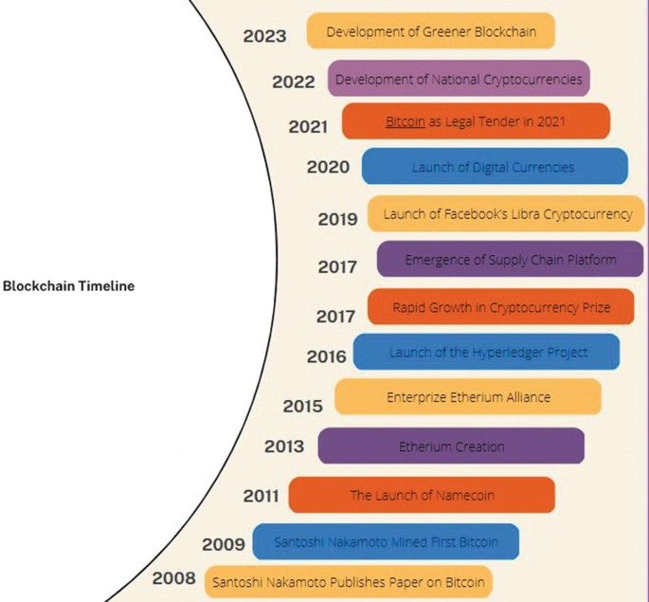

The current growth of blockchain:
- Investment and Market Value: Global investment in blockchain startups reached over USD 8.2 billion in 2021. By 2022, the global market size was valued at USD 10.02 billion, with a projected annual growth rate of 87.7% through 2030.
- Enterprise and Government Adoption: Major corporations like IBM, Walmart, and Visa are actively using blockchain for supply chain and payment processing. Governments are also exploring its use for voting systems and Central Bank Digital Currencies (CBDCs).
- Cryptocurrency and NFTs: The total cryptocurrency market capitalization exceeded USD 2 trillion in 2021. Additionally, the rise of Non-fungible Tokens (NFTs) has created new digital asset markets in industries like art, gaming, and music.
- Technological Advancement: New solutions like sharding and layer-2 protocols are addressing scalability issues, allowing for faster transaction processing and more widespread use.

Slide 02:

There have 4 types of blockchain.
- Public
- Private
- Consortium
- Hybrid

Public blockchain is an open, permissionless network accessible to anyone with an internet connection. It operates without a central authority, allowing participants to freely join, send transactions, and validate blocks.

Key characteristics include:
Transparency & Decentralization: The ledger is shared, and all nodes can verify new data.
Anonymous: Real identities are not required for participation.
Open Access: Nodes can join or leave the network at any time.

Characteristics of Public Blockchain
- Permissionless and open to all
- Cooperation among all nodes to verify data
- Use of incentive mechanism-based protocols
- Shared and transparent ledger
- Secure with 51% rule
- Anonymous and hidden user identity
- Absence of regulations or limitations on participant
- No way to track transactions

Private blockchains are permissioned networks restricted to authorized users or specific organizations. Managed by a single entity, they provide faster transaction speeds and better scalability, helping organizations improve efficiency and reduce costs.

Characteristics of Private Blockchain
- Private blockchains operate in a closed network and have permissions managed by an organization.
- They are suitable for specific use cases where organizations want to exert control over access and network parameters.
- The advantages of private blockchains include faster transaction speeds, better scalability, and customization options.
- Private blockchains go against decentralization and distributed ledger principles.
- Use cases for private blockchains include supply chain management, asset ownership verification, and internal voting systems.

Public vs Private Blockchain

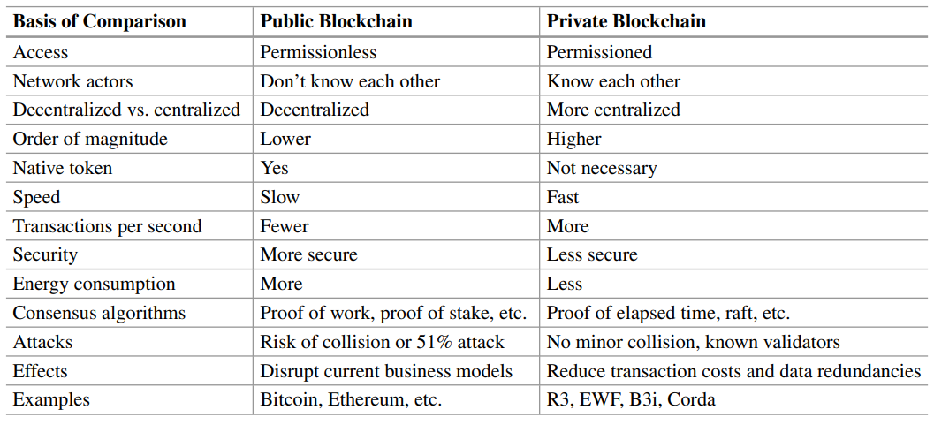

A federated (consortium) blockchain is a permissioned network managed by a group of organizations rather than a single entity. It operates under a federated consensus model, where decision-making is restricted to authorized members. This structure provides faster transaction speeds and enhanced privacy, making it ideal for institutional collaborations.

Characteristics of Federated Blockchain
- Permissioned and accessible only to authorized entities within a consortium
- Consensus achieved through a select group of nodes forming the federation
- Improved scalability and faster transaction speeds compared to public blockchains
- Enhanced privacy and security features
- More centralized decision-making compared to public blockchains
- Suitable for consortium-based collaborations and data sharing

Hybrid blockchain combines public and private models to offer flexible transparency and control. It enables interoperability, allowing different networks to exchange data and assets. While some parts are public for open participation, others remain private to ensure restricted access and enhanced privacy.

Characteristics of Hybrid Blockchain
- Combination of public and private blockchains
- Flexibility in terms of transparency and control
- Interoperability between different blockchain networks
- Customization of decentralization and privacy
- Suitable for applications with varying requirements

Blockchain framework is a comprehensive set of protocols, rules, and standards that define how a blockchain network is structured and how it operates.

It is typically organized into five distinct layers, each responsible for specific functions within the system.

1. Hardware/Infrastructure Layer
This is the bottom-most layer of the framework. It consists of the physical and virtual resources required for the network to function:
Physical Servers: These are hosted in data centers and store the actual content of the blockchain.
Virtual Environment: It utilizes Virtual Machines and Containers to provide the necessary computing resources and isolated environments for blockchain operations.

2. Data Layer
The data layer defines the physical structure of the ledger and how data is stored. It establishes a secure and transparent way to verify information through several components:

Block Structure: Data is organized into blocks containing transactions, timestamps, and pointers to previous blocks, creating a linked list.
Merkle Trees: A binary tree of hashes used to efficiently store and verify large amounts of transaction data while ensuring integrity and immutability.
Security Mechanisms: This layer utilizes digital signatures and hashing to secure transactions and maintain a tamper-proof record.

3. Network Layer (P2P Layer)
Also known as the Peer-to-Peer (P2P) layer, this layer manages communication across the distributed network.

Node Communication: It facilitates transaction and block propagation, node discovery, and synchronization between participants.
Verification: It ensures that all nodes are effectively communicating and propagating valid information to maintain the current state of the blockchain.
Architecture: It relies on a P2P network where every node acts as both a client and a server, sharing resources directly.

4. Consensus Layer
The consensus layer is critical for decentralization, as it provides the rules for agreement without a central authority.

Validation: It validates new blocks and ensures they are added in the correct chronological order.
Integrity and Fairness: By achieving agreement among participants, it prevents manipulation and ensures the security of the ledger.
Algorithms: This layer uses various protocols to reach agreement, such as Proof of Work (PoW), Proof of Stake (PoS), and Practical Byzantine Fault Tolerance (PBFT).

5. Application and Presentation Layer
This is the user-facing part of the blockchain that allows for interaction with the underlying network.
User Interface: It provides a Graphical User Interface (GUI) for users through applications like wallets, browsers, and NFT platforms.
Programming & Logic: This layer contains smart contracts, chaincode, and decentralized applications (dApps) that define the business logic and programmable features of the network.
APIs and Execution: Applications interact with the blockchain using Application Programming Interfaces (APIs), while a "semantic layer" handles the actual execution and validation of these high-level transactions.

Slide 03: Block and Block Structure

A block is an essential blockchain component comprising a collection of transactions.

Its structure includes a preamble (metadata: timestamp, parent block reference) and a body (actual transaction data). Unique cryptographic hashes ensure integrity, chaining blocks chronologically into a secure, immutable ledger. Once validated, a block closes, and a new one is created for subsequent transactions.

Structure of a block
The structure of a block typically consists of several key components that ensure its security and placement within the ledger:
- Block Header: Contains essential metadata, including the block number, timestamp, and the hash of the previous block.
- Nonce: A random number generated by miners to solve the cryptographic puzzle required to add the block to the chain.
- Transaction Data: The actual data added to the blockchain, such as sender/recipient addresses and transaction amounts.
- Block Hash: A unique identifier representing the block's contents, created by hashing the header and transaction data together.
- Merkle Tree: A data structure that hashes transactions in pairs to produce a single root hash, allowing for the efficient storage and verification of large amounts of data.

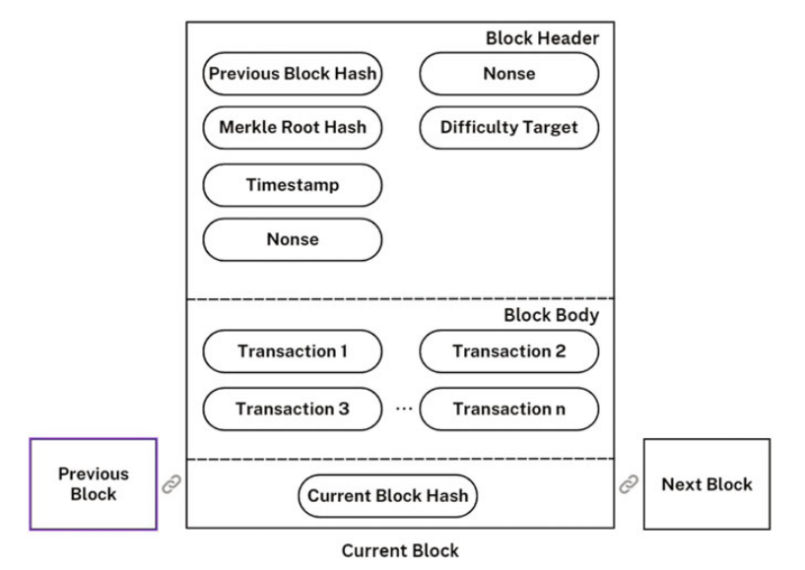
Ledger
A ledger is a decentralized, digital record-keeping system that provides a permanent, tamper-proof, and immutable record of all network transactions. It is commonly called a distributed ledger because no central authority controls it; instead, every node maintains an identical copy that is updated in real-time and visible to all participants.

Distributed
Distributed refers to an architecture where data storage and processing are shared across a network of nodes rather than held in a single central location. Each node is responsible for maintaining a complete copy of the blockchain and verifying transactions to ensure the integrity of the entire network.

How a Distributed Ledger is Created
A distributed ledger is created through collective record-keeping:
Announcement: When a transaction occurs (e.g., Resident A lends money to Resident B), both parties publicly announce the details to the entire network.
Record-Keeping: Every other participant (Nodes C, D, and E) hears the announcement and independently records the transaction in their own copy of the ledger.
Result: This process ensures that everyone has an identical, synchronized record of the event without needing a central bookkeeper.

Benefits of Distributed Architecture
Distributed systems offer several key advantages by spreading workloads across a network of computers:
- Resource & Data Sharing: Computers connect to share hardware, software, and data, which reduces costs and ensures information consistency.
- Heterogeneity: Different hardware, languages, and networks can work together efficiently.
- Scalability: The system is designed to handle growth in users and computers effectively without changing core components.
- Concurrency: Enables parallel processing by executing multiple activities simultaneously across different machines.
- Fault Tolerance: Enhances reliability through hardware redundancy and software recovery, ensuring the system stays active despite individual failures.
- Openness: Allows for the seamless integration and adaptation of new components through standardized interfaces.

Transparency
In a blockchain, transactions are public and visible to all nodes, allowing anyone to view details like sender, receiver, and amount. This transparency provides:
- Trust: Allows anyone to verify that transactions are valid and executed properly.
- Accountability: Ensures all participants are responsible for their actions on the network.
- Fraud Prevention: Makes malicious activities and fraud significantly more difficult to commit.
- Efficiency: Reduces costs and improves speed by removing the need for intermediaries.

Confirmation
Block confirmation is the critical process of validating transactions and adding them to the ledger:
- Process: It involves solving mathematical puzzles to ensure data integrity and prevent double-spending.
- Mining: Once validated, transactions are added to a block and appended to the chain through mining.
- Security: Confirmation makes transactions permanent and immutable, meaning they cannot be altered.
- Impact: This process enhances network efficiency and reduces transaction costs by eliminating intermediaries.

1. Centralized Systems
A system where control, data processing, and decision-making are handled in one single location or entity.
How it Works: A central unit (server or mainframe) handles most tasks like data storage and processing, while "client" machines just interact with this center.

Key Features:
Single Point of Control: One authority manages all resources and administration.
Centralized Storage: All data stays in one place for easier management.
Client-Server Interaction: Peripheral units send/request data but don't do the heavy processing.
Simplified Management: Since there is one main location where tasks are handled, management, monitoring, and troubleshooting can be more straightforward

Pros:
Ease of Management: Administrators can oversee everything from one point.
Consistent Policies: Updates and rules are uniform across the whole system.
Simple Backups: It is easier to secure and copy data in one location.
Cons:
Single Point of Failure: If the center fails, the entire system stops.
Scalability Issues: The central unit may struggle as data and requests increase.
Performance Bottlenecks: All tasks must pass through one point, causing delays.

2. Decentralized Systems
An architecture where control and decision-making are spread across multiple independent nodes instead of one central authority.

Key Features:
Distributed Control: Authority is shared among many participants.
Fault Tolerance: No single point of failure; if one node fails, the rest continue working.
Scalability: New members can join without overwhelming a central server.
Security & Privacy: Data can be encrypted or spread out to make tampering harder.
Autonomy: Participants make decisions based on their own inputs without needing a central "green light".
Advantages:
Resilience: The system stays active even if parts of it go down.
Efficiency: It leverages resources across many different nodes.
Trust: Transparency is often built-in (like in blockchain), allowing trust without a middleman.
Disadvantages:
Complexity: Harder to design and coordinate, especially for reaching agreement (consensus).
Data Consistency: Keeping every node's data identical in real-time is challenging.
Security Risks: Communication protocols between nodes can have vulnerabilities.
Use-Cases: Blockchain (Bitcoin, Ethereum), Peer-to-Peer Networks, DeFi (Decentralized Finance), and Distributed Databases.

3. Distributed Systems
A collection of independent computers that work together to appear as one single system to the user.

Key Characteristics:
Multiple Nodes: Machines often located in different physical spots.
Communication: These nodes communicate over a network using protocols such as TCP/IP or HTTP.
Concurrency: Nodes perform tasks simultaneously, requiring careful synchronization.
Fault Tolerance: Designed to survive the failure of one or more nodes.
Transparency: Complexity (like where data is located) is hidden from the user.

Types: Client-Server, P2P, Cloud Computing (AWS, Azure), and Microservices Architecture.

Challenges:
Synchronization: Managing many tasks happening at once.
Consistency: Ensuring every node sees the exact same data.
Network Latency: Delays in communication between nodes.
Security: Ensuring that communication between nodes is secure and that data is protected across the distributed system.

Use-Cases: Google Search (indexing across many servers), Distributed File Systems (Hadoop, GFS), and Blockchain.

4. Peer-to-Peer (P2P) Networks
A decentralized model where all participants (peers) have equal privileges and responsibilities.

Key Features:
Dual Roles: Every peer acts as both a client and a server.
Direct Communication: Resources like files or bandwidth are shared directly between peers.
Cost-Efficiency: No need for expensive central infrastructure.

Types of P2P:
Structured: Organized in a specific way for very fast data searching (e.g., BitTorrent's DHT).
Unstructured: Nodes connect randomly; easy to set up but slower to search (e.g., Gnutella).
Hybrid: A central directory helps peers find each other, but the actual data sharing is P2P.

Pros & Cons:
Pros: No single point of failure, efficient resource use, and resilience against censorship.
Cons: Harder to secure, vulnerable to "malicious peers," and potential legal risks.

Use-Cases: File sharing (BitTorrent), Cryptocurrencies, Communication Tools(Skype), and Distributed Computing projects.

